CSCI 520
Programming Assignment #4

To be done in the lab
(Friday,9/30/2016, JOUR 102, 2:30-4:10pm)

Turn in your work in the drop box for Assignment 4 (for Week 4) in eCollege course shell for 520.

Simulate an array by a linear linked list:

Let A be an array that stores up to n (n=100 here) integers. We will use a linked list L to represent A. Your task is to write a C++ program that simulates operations on A by using L, and outputs results.

The following is an example snapshot of L and A at some given time:

int A[8]; A[1]=5; A[3]=2; A[4]=1; A[6]=7

/* node definitions for L */
struct node {
int index;
int data;
node* next;
};
typedef node *link;
AGAIN ASSUME THAT THE LIST DOES NOT CONTAIN MORE THAN 100 ELEMENTS

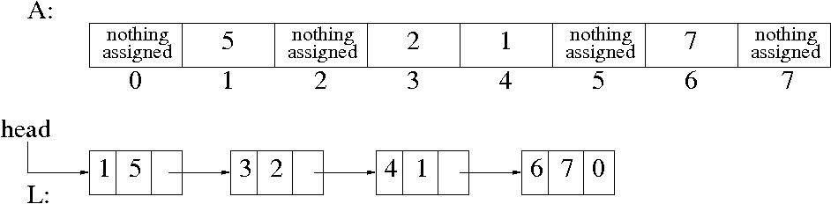

Do the following operations on L (the operations are defined on A; we need to perform equivalent operations on L):

HERE WE IMAGINE OPERATIONS ON A, BUT ACTUALLY DO THEM ON L, AND ALL ELEMENTS IN THE LIST ARE DISTINCT

A ix : Set A[i]=x
T : Output all data values in A (only the final assigned value, other parts are not used in A)
R: Resets A. All elements are reset meaning that there is no data in A.
I: Increment by 1 all elements of A.

Sample input/output:
A 1 5
A 3 4
A 4 1
A 6 7
A 3 2
I
T
index: 1 value: 6
index: 3 value: 3
index: 4 value: 2
index: 6 value: 8
R
A has been reset
T
No data in A now
A 1 5
T
index: 1 value: 5

Good Luck
Abdullah N. Arslan

CSCI 520
Programming Assignment #4

Due: 11:59pm, Thursday, Oct. 6, 2016

Turn in your work in the drop box for Assignment 4 (for Week 4) in eCollege course shell for 520 (as always use a different name for programs for lab and course assignments).

Simulate a linear linked-list by an array
Let L be a linear linked list. We will use array A to represent L. Your task is to write a C++ program that simulates operations on L by using A, and outputs results.

The following is an example snapshot of L and A at some given time:

struct node {
int data;
int next;
};
struct node A[100] ;

ASSUME THAT THE LIST DOES NOT CONTAIN MORE THAN 100 ELEMENTS, AND ALL ELEMENTS IN THE LIST ARE DISTINCT

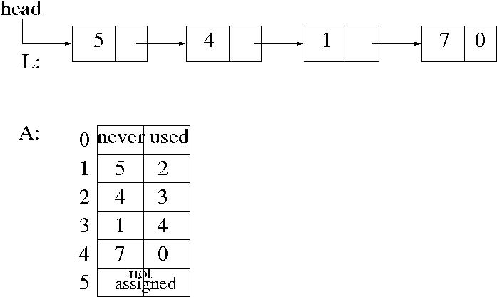

Again, we assume that each node in L contains a distinct data value
Do the following operations on A:

HERE WE IMAGINE OPERATIONS ON L, BUT ACTUALLY DO THEM ON A
NEVER USE A[0]
THE next field in A[i] GIVES YOU THE SUCCESSOR NODE
YOU MAY USE ADDITIONAL VARIABLES FOR HEAD AND LAST NODES
YOU MAY USE -1 IN THE NEXT FIELD TO MARK THE FREE CELLS IN A, AND WHEN YOU NEED A CELL FOR NEW NODE YOU CAN USE THESE FREE CELLS

A y : Create a new node with data value y, and append this node to L

I x y : Find the node t with value x, create a new node p with data value y, and insert node p after t in L

D y : Find the node with data value y, and delete that node from L

P: Double (multiply by two) all existing values (not indices) in nodes of L.

R : Reverse L

T : Output all data values in L

Sample Input/Output:

A 5
A 1
I 5 4
I 1 9
A 7
I 9 8
D 9
D 8
T
5 4 1 7
R
T
7 1 4 5
P
T
14 2 8 10

Good Luck
Abdullah N. Arslan

CSCI 520

Programming Assignment #4

Due: 11:59pm, Thursday, Feb. 16, 2017

Turn in your work in the drop box for Assignment 4 (for Week 4) in eCollege course

shell for 520 (as always use a different name for programs for lab and course

assignments).

Simulate a linear linked-list by an array

Let L be a linear linked list. We will use array A to represent L. Your task is to write a

C++ program that simulates operations on L by using A, and outputs results.

The following is an example snapshot of L and A at some given time:

struct node {

int data;

int next;

};

struct node A[100] ;

ASSUME THAT THE LIST DOES NOT CONTAIN MORE THAN 100 ELEMENTS,

AND ALL ELEMENTS IN THE LIST ARE DISTINCT

Again, we assume that each node in L contains a distinct data value

Do the following operations on A:

HERE WE IMAGINE OPERATIONS ON L, BUT ACTUALLY DO THEM ON A

NEVER USE A[0]

THE next field in A[i] GIVES YOU THE SUCCESSOR NODE

YOU MAY USE ADDITIONAL VARIABLES FOR HEAD AND LAST NODES

YOU MAY USE -1 IN THE NEXT FIELD TO MARK THE FREE CELLS IN A, AND

WHEN YOU NEED A CELL FOR NEW NODE YOU CAN USE THESE FREE

CELLS

A y : Create a new node with data value y, and append this node to L

I x y : Find the node t with value x, create a new node p with data value y, and insert node

p after t in L

D y : Find the node with data value y, and delete that node from L

T : Output all data values in L in the order they appear in L (as in a linked list traversal)

Sample Input/Output:

A 5

A 1

I 5 4

I 1 9

A 7

I 9 8

D 9

D 8

T

5 4 1 7

Good Luck

Abdullah N. Arslan

